Activity 6-1 Report
Student: Md Azizul Rahaman
Environment: Kali Linux & Windows 10 Virtual Machines
Objective
The objective of this activity is to learn how to use the NBTscan tool in Kali Linux to discover computers running NetBIOS on the local network. NBTscan scans an IP range and displays important details such as NetBIOS names, IP addresses, and MAC addresses of Windows systems.
Description
In this activity, we work individually or with a partner to identify Windows machines on the network. One machine runs Kali Linux, and the other runs Windows. The NBTscan tool is used from Kali Linux to scan an entire IP range to check which devices respond with NetBIOS information.
Step 1 — Choose Operating Systems
If working with a partner:
- One person boots into Windows
- The other boots into Kali Linux
If working alone (as I did):
- Use two virtual machines
  - Kali Linux
  - Windows 10
This setup allows scanning one machine from another on the same network.
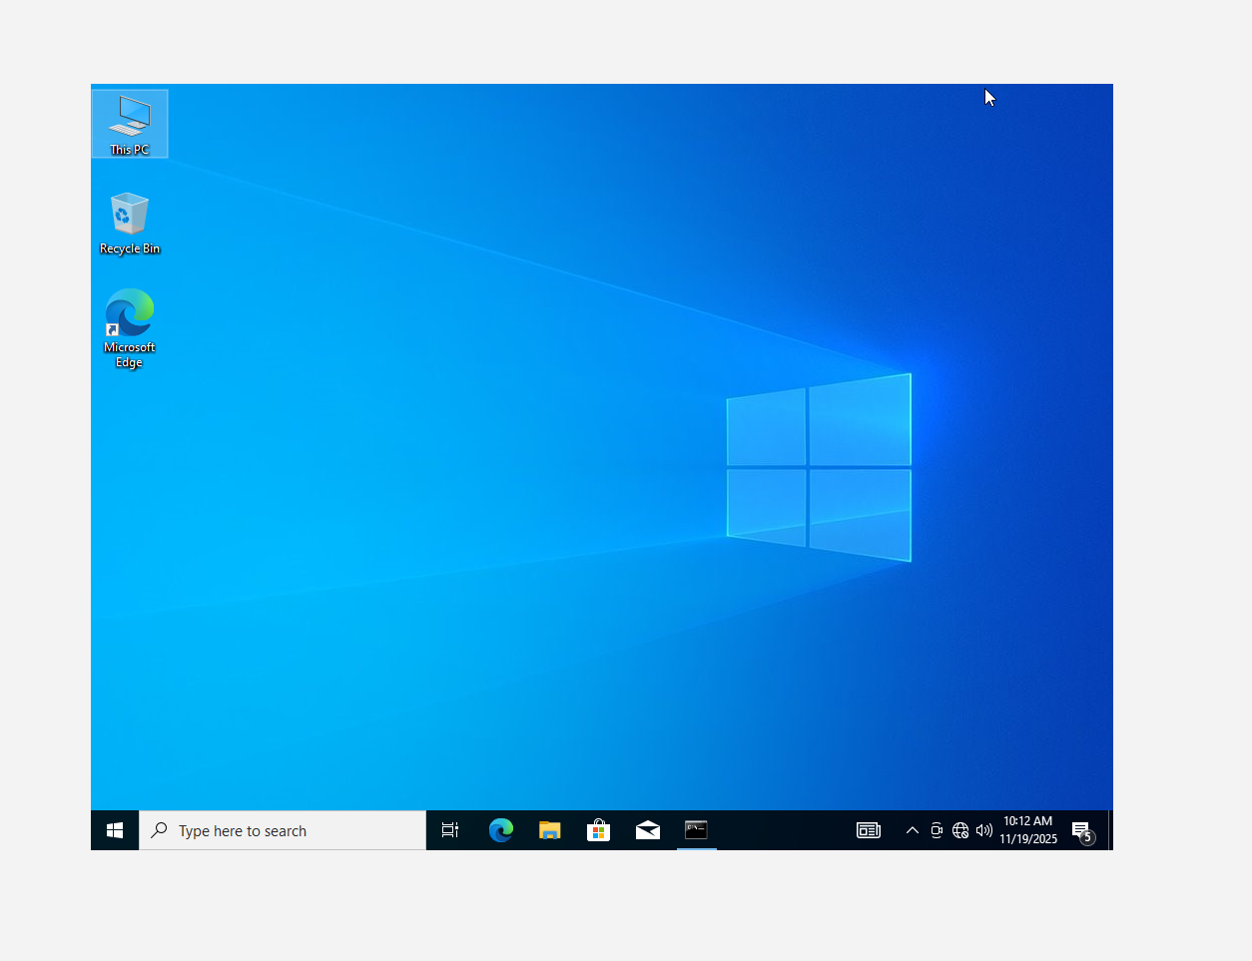
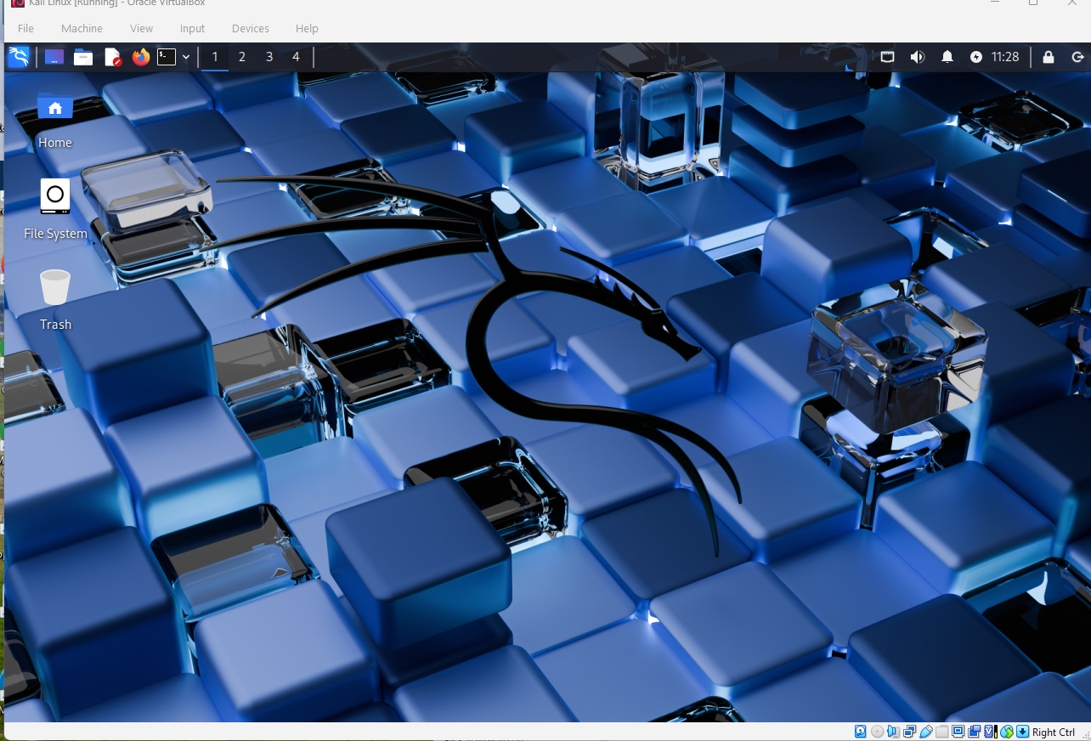

Step 2 — Run NBTscan from Kali Linux
2.1 Open Terminal in Kali
I opened a terminal by clicking the Terminal icon.
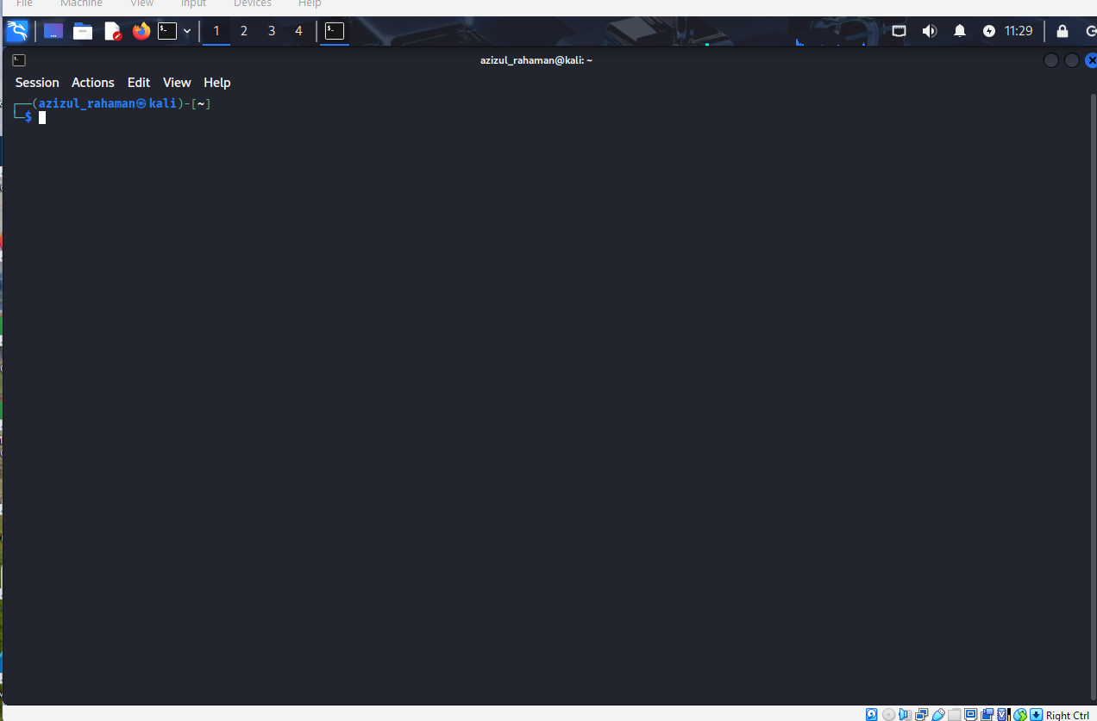
2.2 View the NBTscan Help Page
I entered the following command: nbtscan -h | less
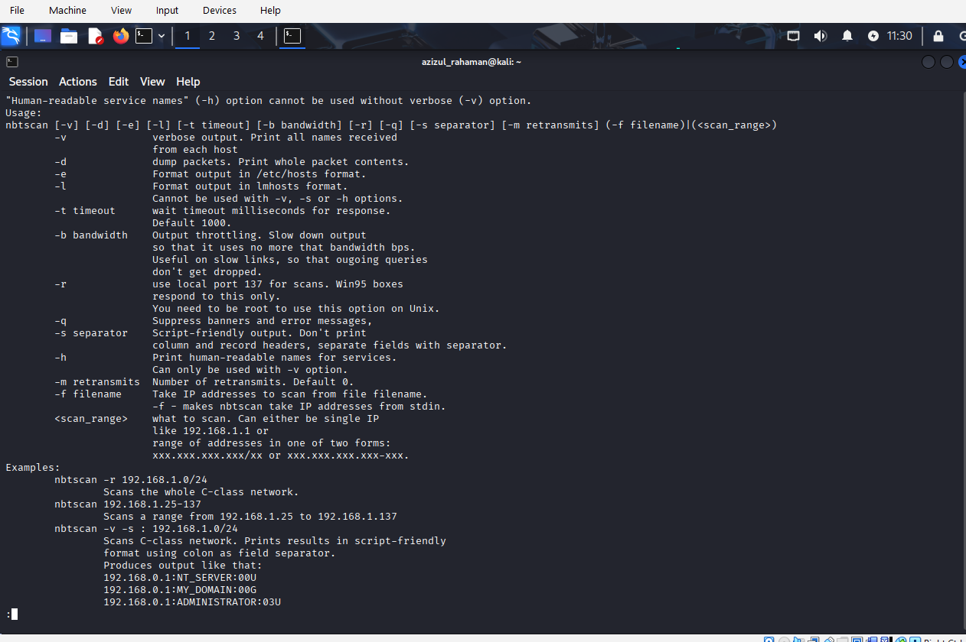
This displays the NBTscan help menu, which explains available options and command syntax.

2.3 Identify the Network Range
I checked my network range and found that my VM was using:
192.168.1.0/24
This is a typical home/VM LAN network.
2.4 Scan the Entire Network Using NBTscan
I entered the following scan command:
nbtscan 192.168.1.0/24
NBTscan scanned all 256 IP addresses in the range and displayed systems responding with NetBIOS data.

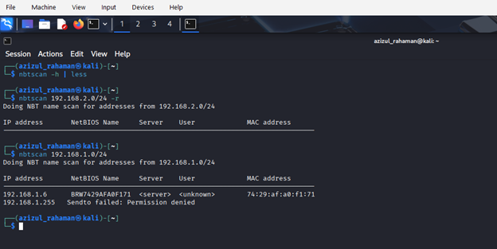
2.5 Scan Results
The scan returned the following output:
192.168.1.6 BRWY429AFA0F171 <server> <unknown> 74:29:af:a0:f1:71
192.168.1.237 DESKTOP-I774B9H <server> <unknown> 08:00:27:9d:7c:08
192.168.1.255 Sendto failed: Permission denied
Identification of Windows Machine
The system with the NetBIOS name:
DESKTOP-I774B9H
is my Windows 10 virtual machine, meaning NBTscan successfully detected the Windows host.
This confirms NetBIOS is running and responding from Windows.

Activity 6-2
1. Objective
The objective of this activity was to learn how to use the built-in Windows NetBIOS tools—Nbtstat, Net view, and Net use—to discover shared folders, enumerate network resources, and check NetBIOS information on a remote system.

2. Description
In this lab, two systems (or two VMs) communicate with each other using NetBIOS over TCP/IP. One Windows machine creates and shares a folder, and the other system attempts to view and connect to that shared folder using Windows command-line tools.
Even when some commands fail (due to firewall or VM network isolation), the activity is considered complete as long as the commands were attempted and the results recorded.
3. Step-by-Step Procedure
Step 1 — Start Windows
I started my Windows 10 virtual machine and logged in

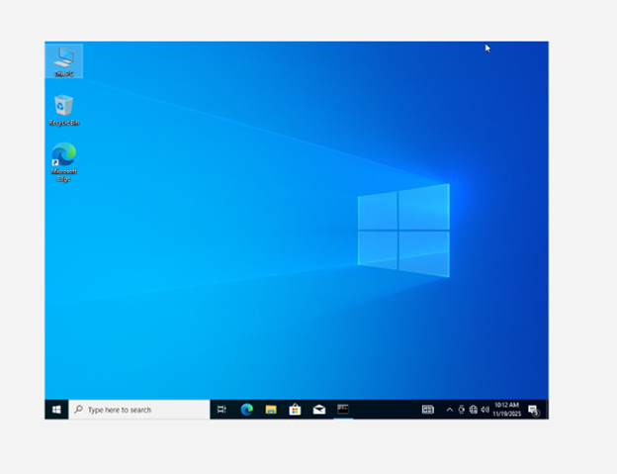
Step 2 — Create a New Folder
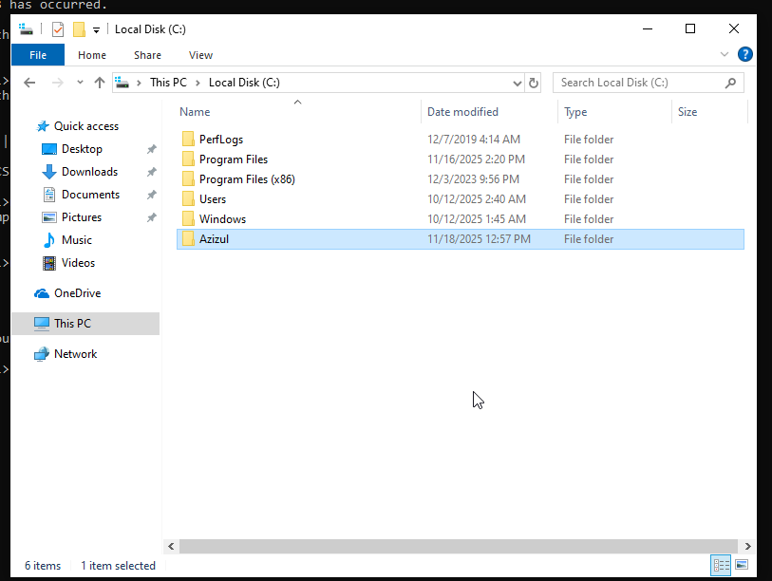
Step 3 — Share the Folder
I right-clicked the folder → Give access to → Specific people
Added Everyone → Clicked Share → Clicked Done
This made the folder accessible to other systems on the same network

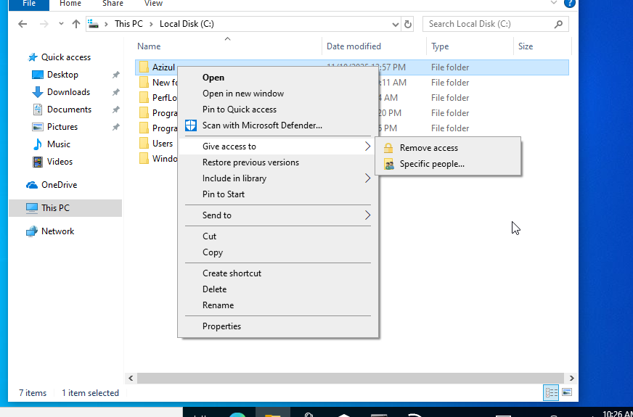
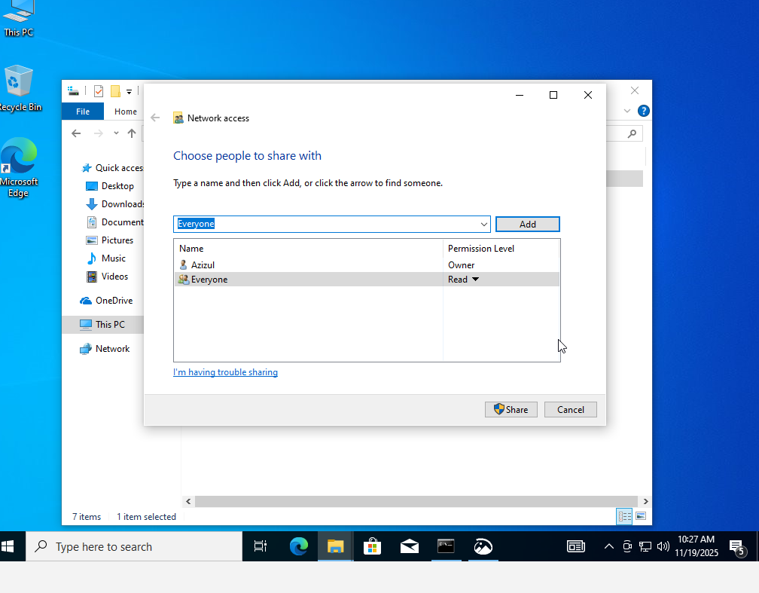
Step 4 — Check My IP Address
I opened Command Prompt and typed:
ipconfig
My IPv4 address was:
192.168.1.237
This is the IP address shared with my “partner” VM.

Step 5 — Use net view to Detect Shares
I attempted:
net view \\192.168.1.237
Result:
System error 53 has occurred.
The network path was not found.
This usually happens when:
- Windows Firewall blocks SMB
- NetBIOS is disabled
- VMs are isolated in NAT mode
The failed output is still valid for the lab, because the goal is to observe and document results.
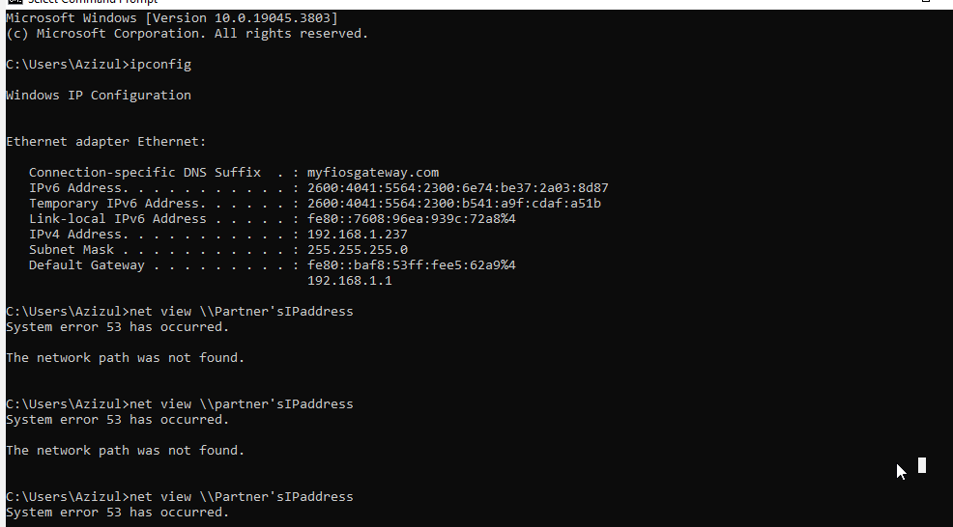
tep 6 — Use net use Help
I typed:
net use ?
This displayed the full help menu for the net use command, showing syntax and available parameters.
tep 7 — Connect to the Shared Folder
I attempted to access the shared folder using:
net use \\192.168.1.237\Azizul
Result:
The command completed successfully.
This confirms that the shared folder was successfully mapped over the network, even though net view failed.
This step demonstrates successful communication with the shared resource.
Step 8 — Use nbtstat -a to View NetBIOS Information
I typed:
nbtstat -a 192.168.1.237
Result:
Host not found.
This is normal in many VM environments because:
- Windows Firewall may block NetBIOS
- NetBIOS over TCP/IP may be disabled
- NAT network mode prevents NetBIOS broadcasts
The important part is that the command was executed and results were recorded.

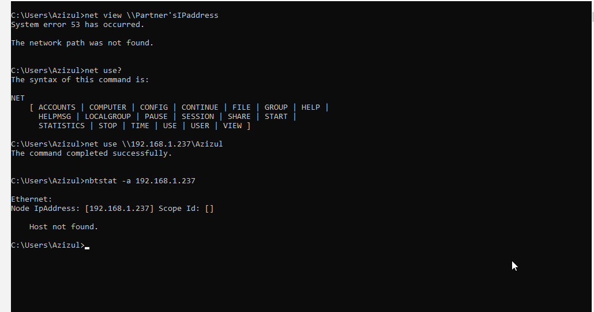
Step 9 — Prepare for Next Activity
I closed Command Prompt and prepared to switch to Kali Linux for the next activity.
Activity 6-3
Objective
The purpose of this activity is to learn how to use Windows enumeration tools included in Kali Linux. By using tools such as enum4linux, the goal is to gather information about a Windows system on the network, including shares, workgroups, usernames, and NetBIOS details.

2. Description
This activity continues the work from earlier labs where one machine runs Windows and the other runs Kali Linux. From Kali, enumeration tools are used to query and attempt to extract information from the Windows target. Modern Windows systems (like Windows 10/11) often restrict anonymous enumeration, so expected results may be limited or show access errors. These outcomes are acceptable and part of the learning process.
Step 1 — Boot Into Kali Linux
I started my Kali Linux virtual machine.
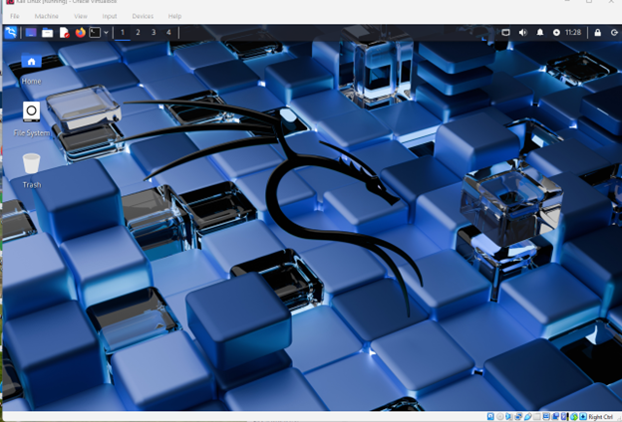
Step 2 — View enum4linux Usage Help
I opened the terminal and ran:
enum4linux -h
This printed the tool’s help menu, including:
- Supported options
- Information about share enumeration
- User and group listing
- RID cycling
- Password policy options
- Notes about samba compatibility
This step confirmed I understand the correct flags for running the tool.
Step 3 — Enumerate Windows Shares
Using the Windows IP address from earlier activities (192.168.1.237), I executed:
enum4linux -S 192.168.1.237
The tool attempted:
- RID cycling
- Workgroup enumeration
- Username guessing
- Session setup attempts
Results:
The enumeration output showed:
- Workgroup name: WORKGROUP
- List of known usernames:
administrator, guest, krbtgt, doma, admins, root, bin, none
- BUT anonymous SMB login was not allowed:
- [E] Server doesn't allow session using username '', password ''.
Aborting remainder of tests.
Explanation:
This is completely normal for Windows 10/11 because:
- Guest access is disabled
- SMBv1 is removed
- Anonymous sessions are blocked
The activity instructions even say:
“Modern versions of Windows hardly provide any information to enum4linux.”
Step 4 — Explore Kali Information Gathering Tools
I opened the Kali Linux Applications Menu → 01 - Reconnaissance / Information Gathering.
(Your screenshot shows the menu clearly.)
This menu provided tools such as:
- Nmap
- smbclient
- nbtscan
- rpcclient
- crackmapexec
- Legion
- Maltego
- SNMP-check
These tools are useful for network enumeration, SMB analysis, OS fingerprinting, and information discovery on Windows networks.
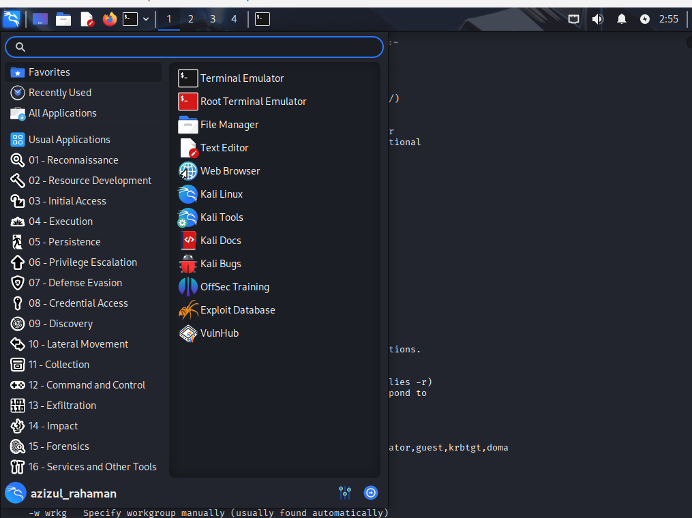
Step 5 — Explore Additional Tools
I spent time reviewing other enumeration and network discovery tools in the menu.
Some tools besides enum4linux and Nmap that can enumerate Windows systems include:
smbclient — lists SMB shares
crackmapexec — SMB, WinRM, LDAP enumeration
rpcclient — query RPC services
nbtscan — NetBIOS enumeration
legion — graphical network scanner
This reinforces how Kali Linux provides multiple tools for Windows enumeration.
Step 6 — Switching Computers
The activity instructs partners to switch systems and repeat the process. Since I am working alone, I simulated the partner’s role using my own VMs and then prepared both systems for the next activity.
Activity 6-4
Step 1 — Boot into Kali Linux
I successfully booted into my Kali Linux system and opened the terminal.
Step 2 — List Linux Service Scripts (/etc/init.d)
I executed:
ls /etc/init.d
From my screenshot, this directory contains important service scripts, including:
- ssh
- smbd
- nmbd
- networking
- apache2
- cron
- mysql
- many more system services
This confirms that both SSH and Samba services are available on my machine.
Step 3 — Start SSH and Samba Services
Starting SSH
I ran:
sudo /etc/init.d/ssh start
Output from screenshot:
“Starting ssh (via systemctl): ssh.service.”
SSH started successfully.
Attempting to Start Samba
I first tried:
sudo /etc/init.d/samba start
Starting Correct Samba Services
I then correctly used:
sudo /etc/init.d/smbd start
and
sudo /etc/init.d/nmbd start
Screenshot result:
“Starting smbd (via systemctl): smbd.service.”
“Starting nmbd (via systemctl): nmbd.service.”
This indicates that Samba file-sharing and NetBIOS components are now active.
Step 4 — Run Scripted Nmap Scan on Localhost
I ran:
sudo nmap -sC -sV 127.0.0.1
Results from your screenshot:
- Nmap 7.95 started successfully
- Host is up
- Two services detected:

Detected Services and Versions
Port 22/tcp – SSH
22/tcp open ssh
OpenSSH 10.2p1 Debian 2 (protocol 2.0)
This is a modern, secure version of OpenSSH.
Port 445/tcp – Samba
445/tcp open netbios-ssn
Samba smbd 4
Samba SMB server version 4 detected.
Nmap Script Results
- SMB2 security mode retrieved
- Message signing “enabled but not required”
- NetBIOS name: KALI
- NetBIOS MAC: unknown (normal on localhost scans)
This confirms Nmap successfully enumerated both services.
Step 5 — Vulnerability Check
OpenSSH 10.2p1 Debian 2
Based on current security data, this version:
- Has no remote code execution vulnerabilities
- Does not suffer from authentication bypass issues
- Is considered secure by default
Samba smbd 4
Samba 4 patched older critical vulnerabilities such as:
- CVE-2017-7494 (“SambaCry”)
- CVE-2012-1182
The version shown in your scan is not vulnerable to these issues.
No major vulnerabilities found for either service.
Step 6 — Stop All Services
After completing the scan, I safely stopped the services:
sudo /etc/init.d/ssh stop
sudo /etc/init.d/smbd stop
sudo /etc/init.d/nmbd stop
Screenshot output:
“Stopping ssh (via systemctl): ssh.service.”
“Stopping smbd (via systemctl): smbd.service.”
“Stopping nmbd (via systemctl): nmbd.service.”
Then I shut down the Kali machine as instructed.
